Project Initialization and Planning Phase
Date | 29 SEPTEMBER 2026
Team ID | SWTID-2026-8700
Project Name | LegalEase – AI-Powered Legal Document Generator
Maximum Marks | 3 Marks
Define Problem Statements (Customer Problem Statement Template):
Create a problem statement to understand your customer’s point of view. The Customer Problem Statement template helps you focus on what matters to create experiences people will love. A well-articulated customer problem statement allows you and your team to find the ideal solution for your customers’ challenges. Throughout the process, you’ll also be able to empathize with your customers, which helps you better understand how they perceive your product or service.
Example:
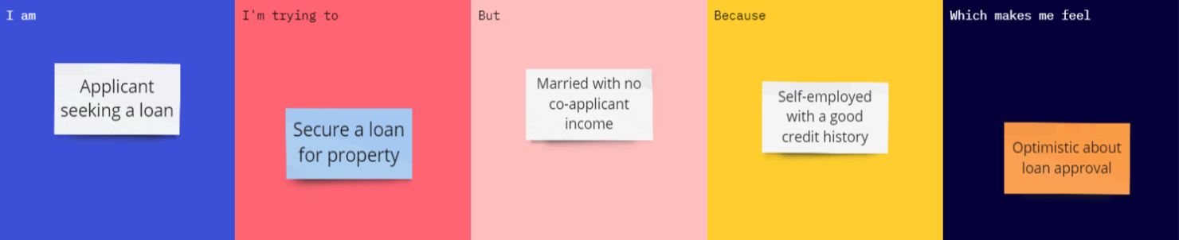
Problem Statement (PS) | I am (Customer) | I’m trying to | But | Because | Which makes me feel
PS-1 | A male applicant seeking a loan. | Secure a loan for the property | Married with no co-applicant income. | Self-employed with a good credit history. | Optimistic about loan approval.
Customer Problem Statements – LegalEase:
Problem Statement (PS) | I am (Customer) | I’m trying to | But | Because | Which makes me feel
PS-1 | A freelancer or small-business owner. | Draft a service agreement or NDA before starting work with a client. | I can’t afford a lawyer for every routine document. | I have no legal training and generic online templates don’t match my terms. | Anxious about leaving out something important.
PS-2 | A legal assistant at a small law firm. | Prepare first drafts of routine agreements quickly. | Retyping the same clauses takes hours. | Every draft needs a clear structure and must be free of errors. | Stretched for time on repetitive drafting.
PS-3 | A person drafting a contract with an AI tool. | Get a draft that uses only the details I provide. | Chatbots often invent names, dates or amounts. | General-purpose AI fills gaps by guessing instead of flagging them. | Unsure whether I can trust the draft.
PS-4 | A startup founder. | Get a branded, editable document I can send to a client. | AI output is plain text that needs reformatting. | Most tools can’t export to Word or PDF or add a company logo. | Frustrated at losing time on formatting.

